**Name: Kartikeya Narian Khanna**

**SAP ID: 50078285**

**Roll No: R171219049**

**Course: B.Tech CSE Devops**

**Batch: 2**

**Build and Release Management Lab-3**

**Aim :** Create maven project and test with Junit

Code 1

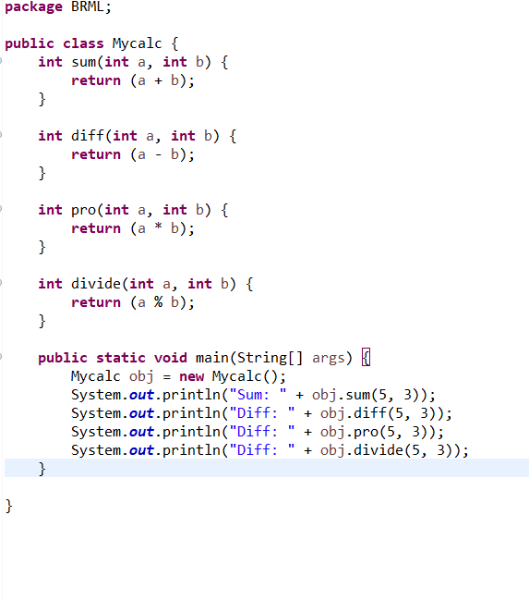

Code 2

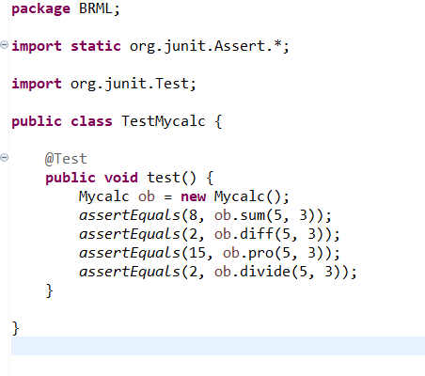

Pom.xml

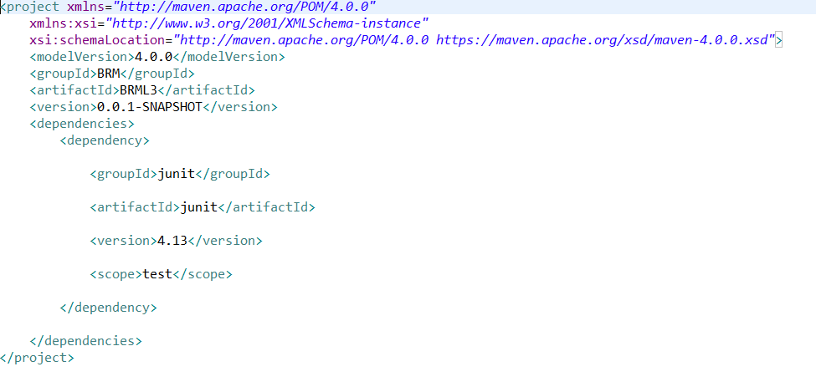

Junit Test

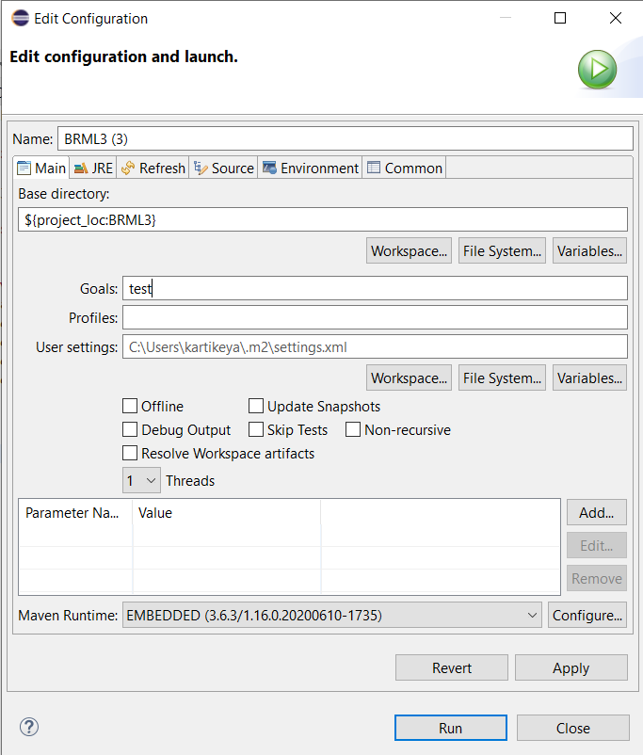

Output

